Mitosis and Meiosis
Dear fellow colleagues, the embryology course that you’ve been submitted to, requires the slides &the documents that the doctor uploads as the material for the exam, these sheets are written to the purpose of understanding the lectures and they are not required in the exam,
thank you.

Let’s start with the definitions of Mitosis and Meiosis:

Mitosis is the process of cell division that forms two genetically identical nuclei from one parent cell nucleus. It is used for:
Asexual reproduction (e.g. Paramecium)
Growth (increasing cells number)
Repair and Maintenance (replace damaged cells with identical replacements)

The stages of Mitosis:

Interphase – (including G1, S, G2 phases) this is where the cell prepares to divide by growing, storing energy, replicating organelles and replicating DNA and it’s the non-dividing phase.

Prophase – Starting the dividing phase, the chromosomes supercoil and become visible under a light microscope. The chromosomes assume their classic 'X' shape - two sister chromatids joined in the middle at the centromere. Other key events are: Nuclear Envelope breaks down; Centriole divides in two, travels to opposite poles of the cell to form the spindle.

Metaphase - Metaphase is characterized by the chromosomes lining up, single file, along the middle (the equator) of the cell. At this point, each chromosome becomes attached to the spindle at its' centromere.

Anaphase - Anaphase sees the chromosomes split at the centromere, separating the sister chromatids:
The sister chromatids are pulled apart to opposite poles of the cell
At this point, each chromatid becomes an individual chromosome - identical to the original parent chromosome
Spindle fibers shorten, pulling each chromatid by the centromere - this causes the chromatids to look like V shape .

Telophase - you will see two nuclei starting to form in early telophase; in late telophase you will no longer be able to see the chromosomes, just two complete nuclei at opposite ends of the cell.

Summary of Mitosis stages:
Stage | Main Event | Keyword
Interphase | DNA is replicated, Cell builds up energy reserves and grows. | Increase
Prophase | DNA Packaged - the chromosomes shorten and thicken | Packaging
Metaphase | Chromosomes line up in the middle of the cell | Middle
Anaphase | Chromatids break apart at the centromere and move to opposite poles | Apart
Telophase | Two nuclei formed after nuclear envelopes reform around each group of chromosomes | Two (nuclei)

Now, let’s move on to the definition of Meiosis,

Human body cells have 46 chromosomes. These are arranged in pairs, with one copy of each chromosome from Mum, and the other from Dad. If your sperm and eggs were made using mitosis, when these two cells fused at fertilization, the zigot would have 92 chromosomes. Definitely not human!

Meiosis is the process of cell division that halves the chromosome number and makes gametes (human gametes contain 23 chromosomes). This ensures that at fertilization the number of chromosomes found in normal body cells - the diploid number - is restored.

In many ways, meiosis is a lot like mitosis. The cell goes through similar stages and uses similar strategies to organize and separate chromosomes. In meiosis, however, the cell has a more complex task. It still needs to separate sister chromatids (the two halves of a duplicated chromosome), as in mitosis. But it must also separate homologous chromosomes, the similar but nonidentical chromosome pairs an organism receives from its two parents.
These goals are accomplished in meiosis using a two-step division process. Homologue pairs separate during a first round of cell division, called meiosis I. Sister chromatids separate during a second round, called meiosis II.
Since cell division occurs twice during meiosis, one parent cell can produce four gametes . In each round of division, cells go through four stages: prophase, metaphase, anaphase, and telophase.

In Meiosis I, Prophase is different than in Mitosis, crossing over happens in this stage:

The stages of Prophase I:
Prophase I is divided into 5 distinctive sub-stages:
- Leptotene – The chromosomes begin to condense and are attached to the nuclear membrane via their telomeres
- Zygotene – Synapsis begins with a synaptonemal complex forming between homologous chromosomes
- Pachytene – Crossing over of genetic material occurs between non-sister chromatids
- Diplotene – Synapsis ends with disappearance of synaptonemal complex; homologous pairs remain attached at chiasmata (when the four chromatids of the homologous pair are in this position two X overlapping, they are called tetrad)
- Diakinesis – Chromosomes become fully condensed and nuclear membrane disintegrates prior to metaphase I (this sub-stage isn’t required in our course so you can just ignore it)

*Synapsis is the fusion of chromosome pairs at the start of meiosis.
*Synaptonemal complex is a protein structure that forms between homologous chromosomes (two pairs of sister chromatids) during meiosis and is thought to mediate chromosome pairing, synapsis, and recombination.
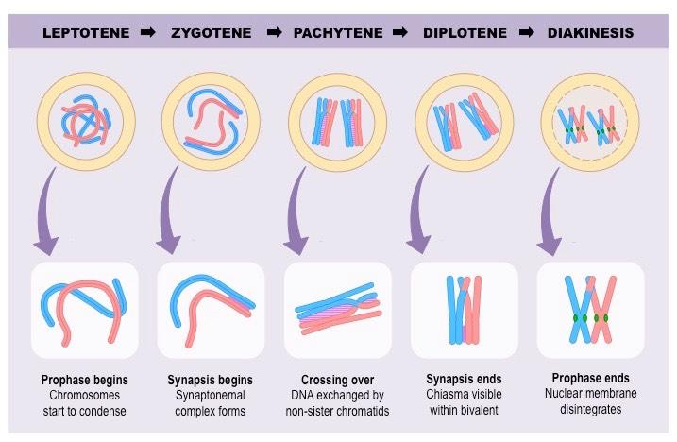

- If the same sex cells of a person produce the gametes every time, how can the siblings be different?

1.Crossing over happens in Prophase I:
For crossing over, you first need to know what Homologous chromosomes are:
- The same size;
- The same shape;
- Have the centromere in the same place;
- Have the same genes.
What is crossing over?
Crossing over (and recombination) is where homologous chromosomes exchange genetic material and create 'recombinant chromosomes.'
During Prophase I, homologous chromosomes line up with each other and swap small amounts of their DNA from similar regions. Without recombination and crossing over, all alleles on a single chromosome would be inherited together. This system creates new gene combinations which increases our capacity (as a species) to respond to environmental change.

2.Genetic assortment also happens in Metaphase: the way the homologous chromosomes line up in the middle may differentiate when producing the gametes in Meiosis which also leads to more different combinations.
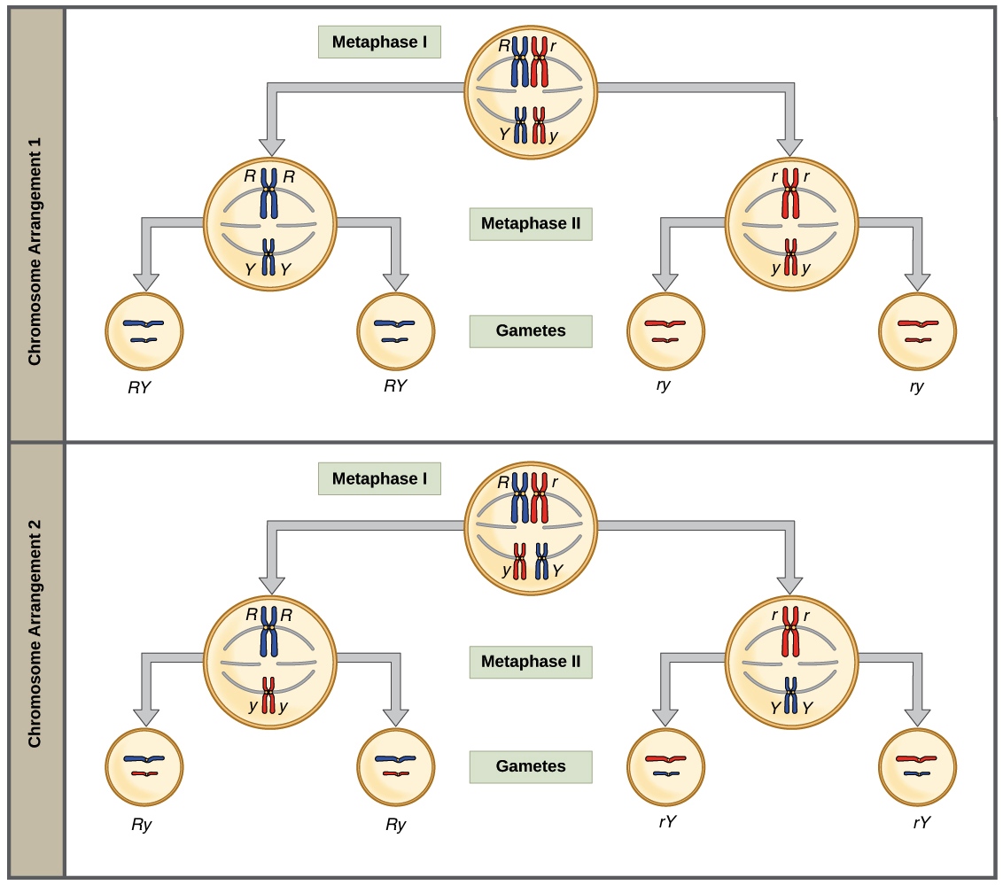

Summary of Meiosis stages:
Stage | Key Event
Prophase I | Chromosomes condense, Crossing over occurs
Metaphase I | Homologous chromosomes pair up and align in middle of cell
Anaphase I | Homologous chromosomes pulled apart
Telophase I | Nuclear Envelope reforms
Cytokinesis I | Cell splits into two
Prophase II | Centrioles divide and move to opposite poles
Metaphase II | Chromosomes attach to spindle fibers and line up along equator
Anaphase II | Sister chromatids break apart at centromere and migrate to opposite poles
Telophase II | Nuclei reform, Chromosomes uncoil

Comparison between Meiosis and Mitosis:
 | Mitosis | Meiosis
Number of daughter cells made | 2 | 4
Are the daughter cells identical | Yes | No (Due to crossing-over and genetic assortment)
Number of nuclear divisions? | 1 | 2
Haploid or Diploid? | Diploid | Haploid
Where does this occur? | Body Cells | Gonads
Do homologous chromosomes pair up? | No | Yes
Function | Growth and Asexual Reproduction | To make sex cells (gametes)

